Christopher Cammel
CS-320
Module 7
Project Two

Summary
While working on this project, as well as any project, I first make sure that every requirement is put into the code in some form. Usually, I do it via comments as a reminder of what I need to do before I start building the programs. Once I have built that part, I delete the comment, so I know that I am done. This helps me know where and how far along the requirements list I am. During the testing phase, this helped me make sure that my Junit tests were effective and that my coverage percentages were above the required amount.
When I was writing the Junit tests, I had to make sure that the code was not only technically sound, but efficient as well. To make sure the programming was technically sound, I regularly ran the tests to make sure everything worked and the coverage met the requirements. With efficiency, I had to make sure that not only was the structure easy to read, but the way the programming was read made sense.
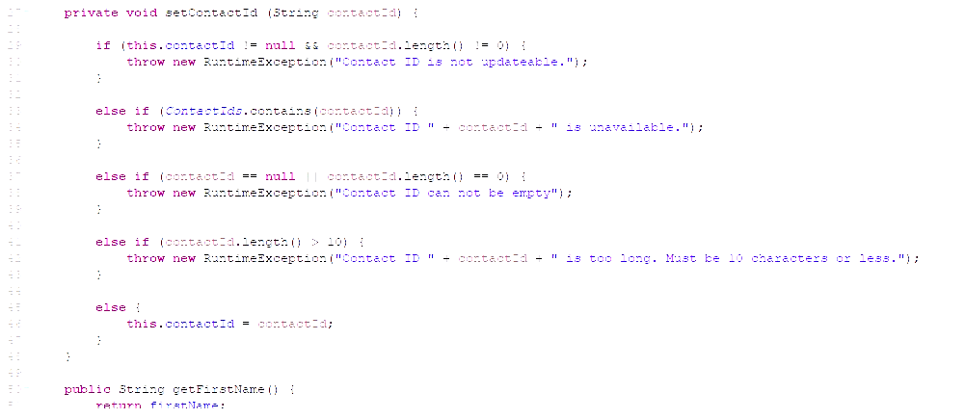
Reflection
The software testing techniques that I used for all the milestones were all in the functional category. My reasoning behind this is that it seemed the most logical way to go through the testing process. Unit testing allowed me to test each individual piece of the software and making sure they worked how they were supposed to. The next technique I used was integration testing. This allowed me to make sure that all the individual units worked well together without errors. Next, I used system testing to test the entire system. When I tested the entire system, this allowed me to make sure that entire project also met the specified requirements. Finally, acceptance testing helped me make sure that the project was ready to be delivered. I used acceptance testing as an end-user would to make sure there were no bugs or errors.
The software testing techniques that I did not use were all under the non-functional category. I did not feel the need to do performance testing, as the program did not require load testing, stress testing, endurance testing, or spike testing. Since this was a closed loop system, security testing was not necessary. I felt that usability testing and acceptance testing could be the same type of testing as both are done as an end-user. Finally, compatibility testing and acceptance testing can go hand in hand as they can both be used to make sure that the program is accepted and compatible with other programs, operating systems, and configurations.
Both types of testing have their uses. Functional testing makes sure that the program works. Starting with individual units working, moving on to the units working together, shifting to the entire system working, and finally having acceptance testing where end-users get to beta test. Every single one of those steps is vital. Non-functional testing is not any less important. Developers want to make sure that the program performs well under load, stress, endurance, and spikes in usage. Engineers need to make sure that a client’s information and the information of their customers is secure with security testing. Making sure that a customer can use the program easily and efficiently without a full degree on just the program is huge. Finally, programmers want to make sure that their finished work can be used across a lot of different systems, which increases sales of said product.
While working on this project, as with most projects, I use caution within reason. Trying to keep requirements in while keeping coverage was extremely complex, but I had to make it work. When testing the coverage, I had to alter my code numerous times, especially in the Contacts application. Keeping the code working with the requirements then having to alter the code to keep coverage was difficult to say the least. I can see where testing and development can have clashes.
Developers need to have as little bias as possible, as do testers. The biggest reason is that one’s ego cannot get in the way. You can be the best developer in the world and your code can still not work in testing. Being biased will only result in time lost and working relationships being strained. As a developer, I need to be creative when a tester finds something wrong. There can be zero errors in the code, but the code will not execute due to coverage. Now as the developer, I need to think of a fix, so the errors stay at zero, but the coverage meets requirements.
Being disciplined in my commitment to quality as a software engineer is extremely important. Cutting corners in development and testing results in poorly written code as well as bad software. As a result, this can turn into lost projects and possibly litigation for giving a client a bad product. To avoid technical debt as an engineer, I plan to only turn in code that I believe in and I am sure will please an end-user. This will require me to write better programs and test them often.

